Chapter 5, Solution 77.

The schematic for the PSpice solution is shown below.

Note that the output voltage, –6.686 mV, agrees with the answer to problem, 5.48.

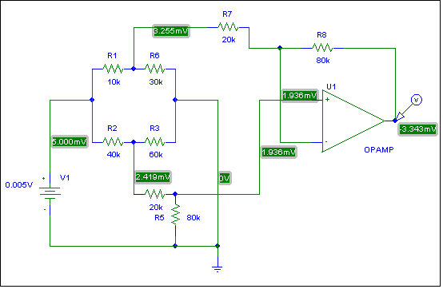
0.0100V
6.510mV
4.838mV
–6.686mV
3.872mV
3.872mV

